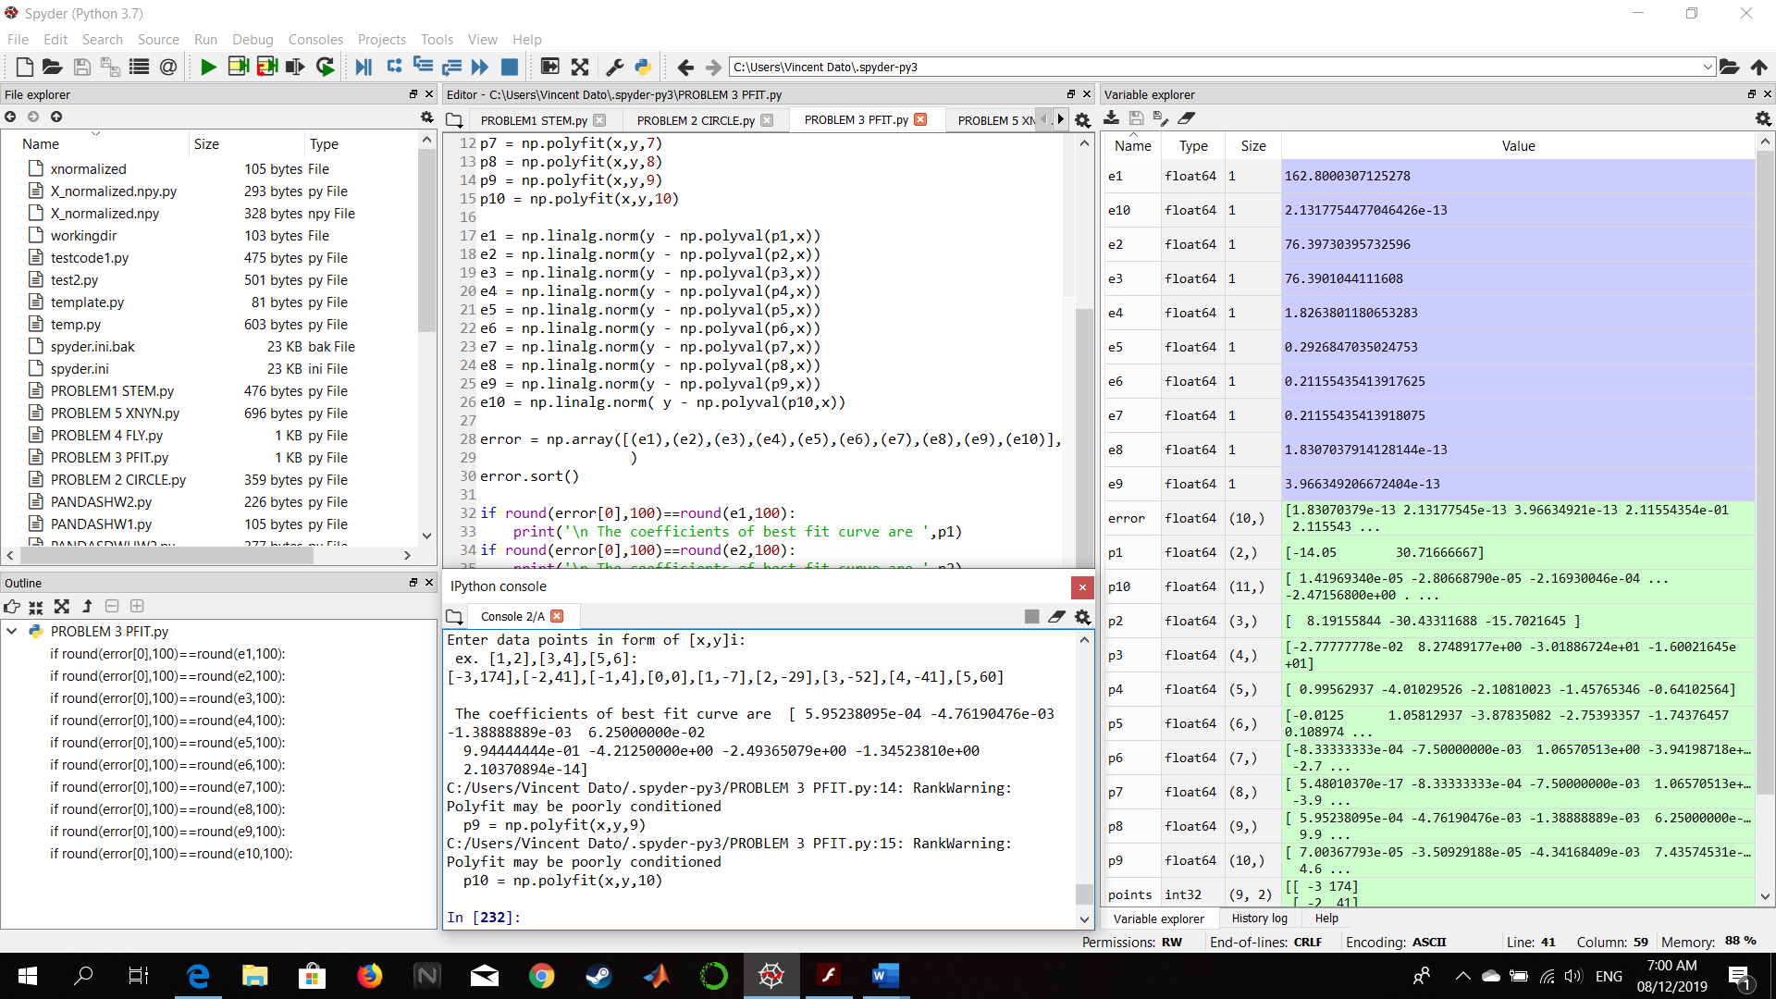PROBLEM 3 – Python

Figure : Input values (-3,174),(-2,41),(-1,4),(0,0),(1,-7),(2,-29),(3,-52),(4,-41),(5,60)

Figure : Screenshot of Code and Output

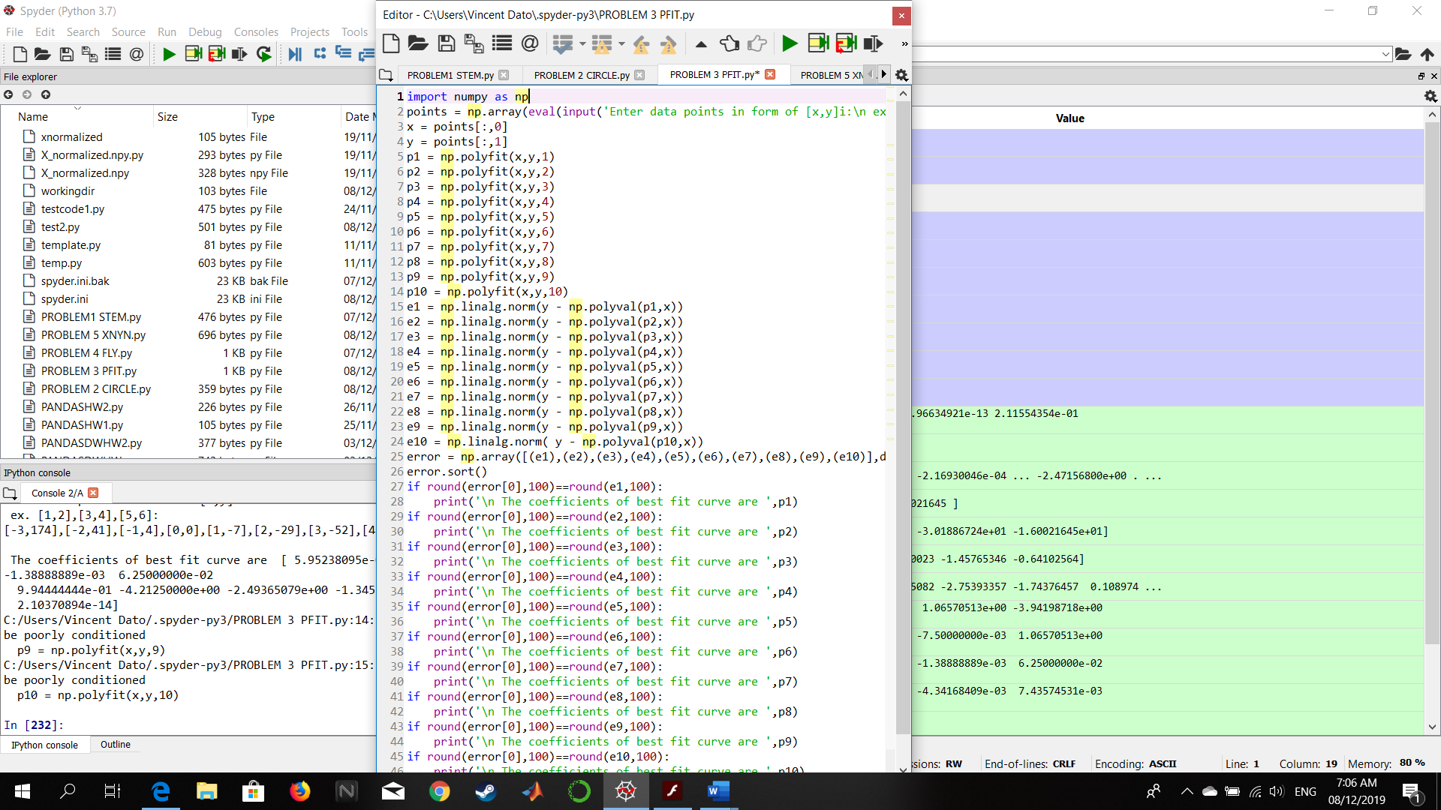

Figure : Screenshot of whole codes

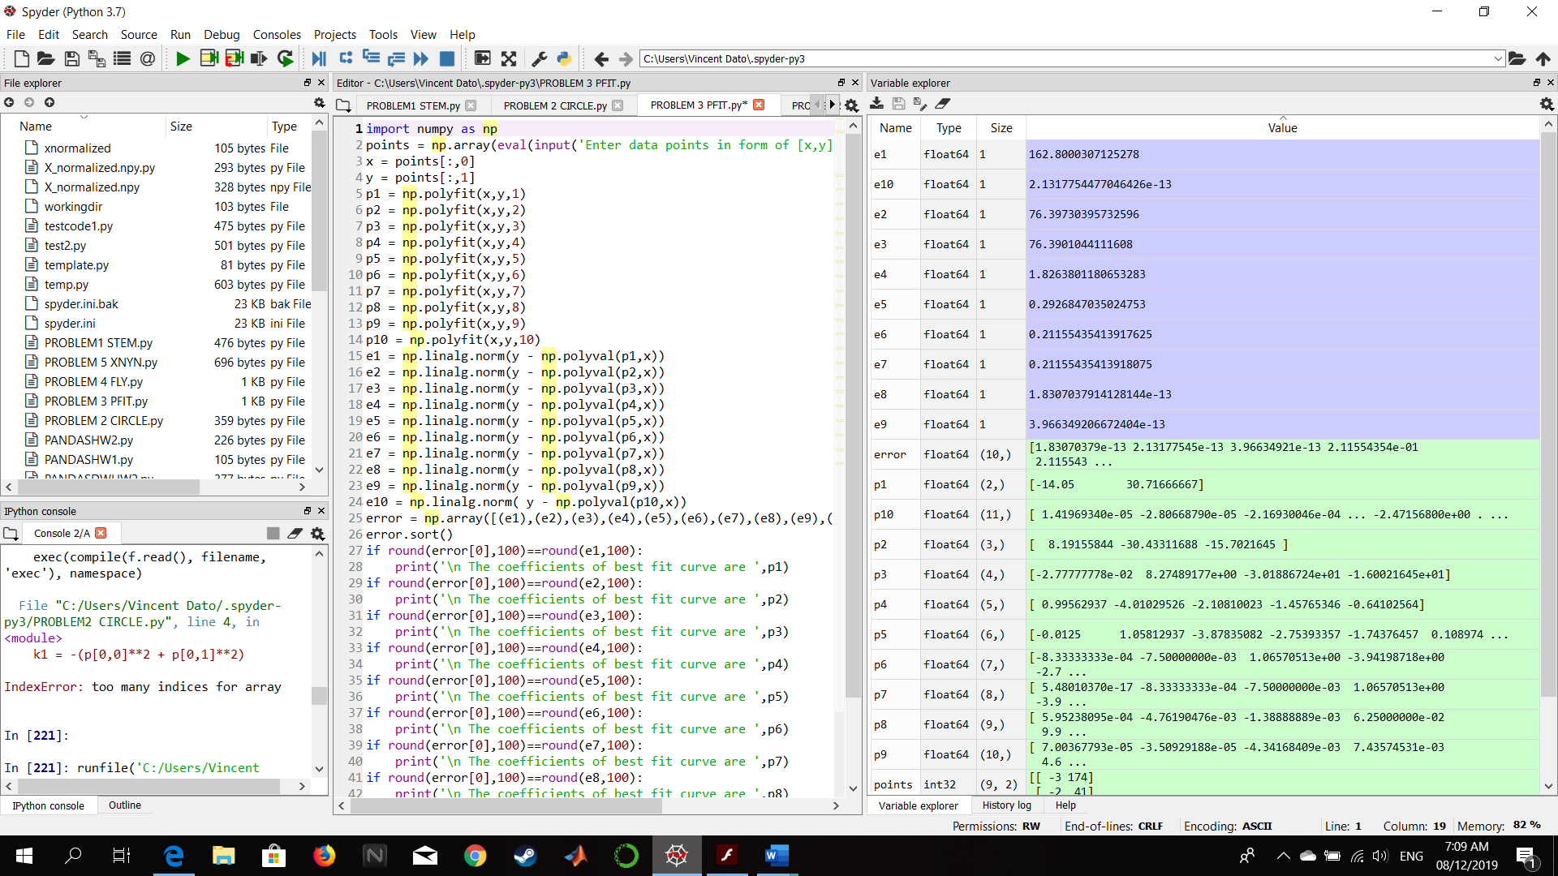

Figure :Input parameter points is in matrix form nx2